NH-02
2016 IE Strategy Memorandum

Updated on 5/24/16
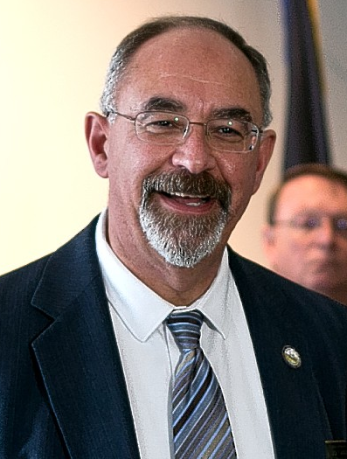
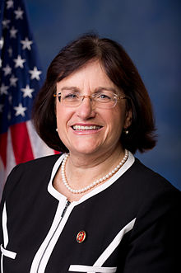

ANNIE KUSTER JACK FLANAGAN
CoH: $1,660,755.31 CoH: $4345.01
Date: 4/15/16 Date: 4/15/16
Occupation: Congresswoman Occupation: State House Rep.
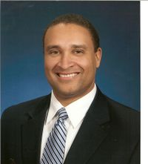

JIM LAWRENCE
Date: (Still officially undeclared)
CoH:
Occupation: Former State Rep/ Veteran/ Businessman

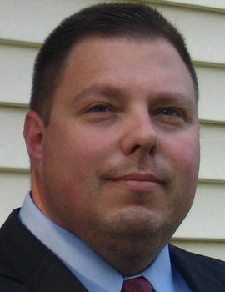

LEN MANNINO
CoH: $0
Date: 4/15/2016
Occupation: Real Estate Broker



ANDY MARTIN
CoH: $0
Date: 4/15/2016
Occupation: Perennial Candidate



CASEY NEWELL
CoH: $0
Date: 4/15/16
Occupation: Mechanic

SECTION I: Race Overview
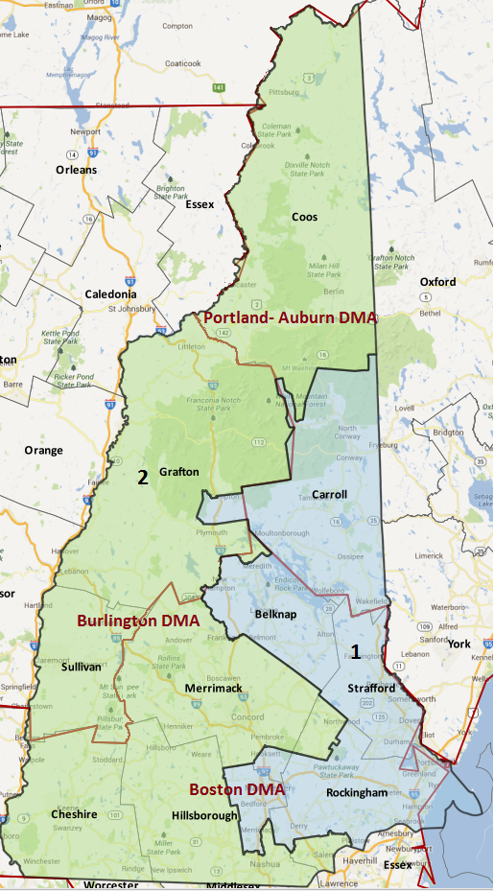
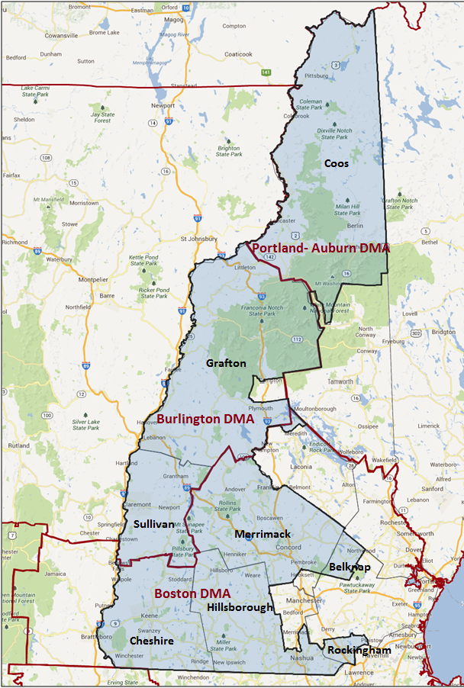

Media Market Costs

TV DMA | % of  CD | I.E.  35+ CPP | Cable CPP
BOSTON | 76% | $950 | $1400
BURLINGTON | 19.6% | $113
PORTLAND | 4.4%
MANCHESTER (WMUR) | 100% | $650
NH-02 TOTALS: | 100.0%
Radio Landscape
DMA | Universe | CPP
Boston | 227,300 | $650
Lebanon | 76,600 | $50
Concord | 103,600 | $50

Digital Landscape
- NH-02
  - Persuasion universe size: 31,410
  - Audience extension (key demos): Independents & Democrats
  - Weekly budget for full coverage: $9,545.76
  - Reach
    - YouTube - 324,985
    - Pandora - 145,783

Presidential Statistics
Cycle | Candidate | Party | Vote
2012 | Obama | DEM | 54.9%
2012 | Romney | REP | 45.1%
2008 | Obama | DEM | 56.5%
2008 | McCain | REP | 43.5%

Congressional Statistics
Cycle | W/L | Candidate | Party | Vote
2014 | W | KUSTER | DEM | 55.02%
2014 | L | GARCIA | REP | 44.98%
2012 | W | KUSTER | DEM | 52.5%
2012 | L | BASS | REP | 47.5%

NCEC Data
Dem Performance: 53.5%
BVAP: .8%
Hispanic: 1.9%
Native Amer.: N/A
Asian: 1.3%
Total Minority: 4%

Critical Dates
Filing Date: June 10th 2016
Primary Date: September 13th 2016

Summary of 2014 Cycle Spending by Outside Groups

TV Competitive Summary – Boston
Campaign/Group | Total GRPs | Total Dollars
Club for Growth | 319 | $188,000
DCCC | 2,347 | $2,568,909
House Majority PAC | 700 | $650,000
Americans for Responsible Solutions | 51 | $62,960
Freedom Partners | 161 | $188,280
Freedom Partners Action Fund | 322 | $376,560
Good Guys vs Bad Guys | Total GRPs | Total Dollars
Good Guys | 3,098 | $3,281,869
Bad Guys | 802 | $752,840
TV Competitive Summary – WMUR
Campaign/Group | Total GRPs | Total Dollars
DCCC/Kuster | 430 | $89,150
Club for Growth | 1,802 | $1,110,550
DCCC | 2,651 | $1,321,709
House Majority PAC | 1,200 | $360,000
Americans for Responsible Solutions | 215 | $96,600
Freedom Partners | 657 | $170,940
Freedom Partners Action Fund | 1,317 | $342,385
Americans for Prosperity | 2,712 | $629,700
Good Guys vs Bad Guys | Total GRPs | Total Dollars
Good Guys | 4,496 | $1,867,459
Bad Guys | 6,488 | $2,253,575
TV Competitive Summary – Burlington
Campaign/Group | Total GRPs | Total Dollars
Club for Growth | 1,222 | $154,310
DCCC | 1,998 | $189,780
Americans for Responsible Solutions | 55 | $7,415
Americans for Prosperity | 1,171 | $165,003
GOPAC | 38 | $4,350
Good Guys vs Bad Guys | Total GRPs | Total Dollars
Good Guys | 2,053 | $197,195
Bad Guys | 2,431 | $323,663

Radio

Radio Competitive Summary – Concord
Campaign/Group | Total GRPs | Total Dollars
Americas PAC | 107 | $8,540
Freedom Partners Action Fund | 268 | $21,570
Good Guys vs Bad Guys | Total GRPs | Total Dollars
Good Guys | 0 | $0
Bad Guys | 375 | $30,110
Radio Competitive Summary – Lebanon/Rutland/White River Junction
Campaign/Group | Total GRPs | Total Dollars
Marilinda Garcia | 95 | $3,885
Freedom Partners Action Fund | 79 | $6,810
Americas PAC | 57 | $4,920
Good Guys vs Bad Guys | Total GRPs | Total Dollars
Good Guys | 0 | $0
Bad Guys | 231 | $15,615
Radio Competitive Summary – Manchester
Campaign/Group | Total GRPs | Total Dollars
Marilinda Garcia | 29 | $7,522
Americas PAC | 20 | $1,740
Freedom Partners Action Fund | 145 | $12,476
Good Guys vs Bad Guys | Total GRPs | Total Dollars
Good Guys | 0 | $0
Bad Guys | 194 | $21,738
Radio Competitive Summary – Rural
Campaign/Group | Total GRPs | Total Dollars
Freedom Partners Action Fund | 19 | $8,731
Good Guys vs Bad Guys | Total GRPs | Total Dollars
Good Guys | 0 | $0
Bad Guys | 19 | $8,731

Summary of 2012 Cycle Spending by Outside Groups

TV Competitive Summary – Boston

Campaign/Group | GRPs | Total Dollars
Kuster / DCCC | 120 | $99,985
DCCC (NH-02) | 1000 | $802,234
DCCC (NH-02 Cable) | 800 | $194,712
NRCC | 1,048 | $859,848
Friends of Democracy | 356 | $88,327
House Majority PAC (Cable) | 50 | $23,448
Good Guys v Bad Guys | GRPs | Total Dollars
Good Guys | 2,326 | $1,208,706
Bad Guys | 1,048 | $859,848
TV Competitive Summary – Manchester (WMUR)

Campaign/Group | GRPs | Total Dollars
DCCC (NH-02) | 1700 | $682,276
NRCC | 1013 | $456,866
House Majority PAC | 1,006 | $442,548
Good Guys v Bad Guys | GRPs | Total Dollars
Good Guys | 2,706 | $1,124,824
Bad Guys | 1,013 | $456,866

TV Competitive Summary – Burlington

Campaign/Group | GRPs | Total Dollars
Friends of Democracy | 67 | $9,836
House Majority PAC | 996 | $78,680
Good Guys v Bad Guys | GRPs | Total Dollars
Good Guys | 1,063 | $88,516
Bad Guys | 0 | $0

Pre-Election Day Voting

Type of  “Early Voting” | Start Date  End Date | Percent of  Vote Cast Using this Method | Brief Description  (where/how  do people vote) | Timeframe (when does the majority of voting happen)
Early Vote
Absentee Ballot/In person Absentee | Absentee Ballots are available approx. 30 days before election 10-8 and voters may return ballots in person up to 5pm day before election 11-5 |  | Request absentee affidavit from town clerk or download, must be witnessed and returned to clerk – ballot then mailed
Vote By Mail

SECTION II: DISTRICT OVERVIEW

- District Overview and Data

  - Political Landscape
- Despite comfortably winning a second term in November 2014, Representative Kuster continues to improve her profile with the electorate. Currently, only 29% of 2nd District adults have a favorable opinion of Kuster, 33% have an unfavorable opinion of her, 8% are neutral, and 30% don’t know enough about her to say. Her net favorability rating is -4%, which is unchanged since July 2015. She is popular among Democrats (net +51%), unpopular among Independents (-16%), and very unpopular among Republicans (-54%). Given that her favorabilities continue to be in the negative, the campaign should consider re-using the 2014 strategy of immediately disqualifying her opponent, while building up the Congresswoman’s positives.
- Republican Jack Flanagan announced his challenge to Kuster on March 8th.
- The New Hampshire congressional primary is September 13, 2016.
- 2014 In 2014, Congresswoman Kuster benefited from a well-run campaign and a late Republican primary that produced a candidate who could easily be portrayed as out of step with the district. In the end, Congresswoman Kuster defeated challenger Marilinda Garcia 55%-45%. Kuster’s monetary advantage ($3.6 million cycle spent by campaign vs. $1.1 million) and lack of a primary opponent enabled her to run two positive pre-primary ads. Kuster’s favorables were underwater in September (38% fav - 42% unfav on 9/12) and remained so in October (37% fav – 46% unfav on 10/5), making it important to disqualify the opponent quickly after the September 9th primary.
Kuster and her team took advantage of the primary by running two positive spots reintroducing her to voters. When Garcia emerged from the primary, both the Kuster campaign and the IE chose to paint Garcia as an extremist, especially on choice and education. This effectively disqualified Garcia before she was able to define herself, preserving a Democratic seat in a Republican wave year. In the end, Kuster won the swing county of Hillsborough with 51.1%, and won every other county with the exception of Rockingham and Belknap.
In a challenging year nationally, Kuster’s 2014 2-way performance was higher in every county than it had been in 2012. She won the district with 55.0% of the vote, compared to 52.5% in 2012. Furthermore, 2012 featured Libertarian Hardy Macia earning 4.4% of the overall vote while 2014 had no major third party candidate.
- In the 2014 election, third party candidates did not garner 1% of the overall vote, while in 2012, Libertarian Hardy Macia earned 4.4% of the overall vote. Kuster defeated her Republican opponent in 2012 by 4.8% of the overall vote.

  - District Demographics
- New Hampshire’s 2nd Congressional District includes the northern and western parts of the state, including the state capital, Concord, and the second-largest city, Nashua. The district includes all of Cheshire, Coos, and Sullivan counties and parts of Belknap, Grafton, Hillsborough, Merrimack, and Rockingham counties.
- The dynamic of the district’s four most populous counties, comprising 80% of the district’s registered voters, characterize the Democratic-leaning tendencies of this district as a whole.
- Hillsborough County, the largest by population at 33.2% of voters, is a swing county where Democrats winning close elections tend to stay within 49-51% support. It contains the district’s largest town, Nashua, at 11.9% of the expected 2016 vote and a DPI of 56.5%.
- Merrimack, Grafton and Cheshire counties, together comprising 46.8% of the district’s voters, have been reliably Democratic in recent years, with the exception of Kelly Ayotte’s landslide Senate victory in 2010, when she won every county in the district. Merrimack includes Concord, the second largest town, with 6.2% of the expected 2016 vote and a DPI of 66.6%. Democrats who have won competitive elections tend to win 55.6%, 60.4%, and 58.6% in Merrimack, Cheshire, and Grafton respectively.
- Only two of the district’s eight counties have 2016 DPIs below 50: Rockingham, which has 9.3% of the district’s expected voters and a DPI of 39.5%, and vote-poor Belknap at 0.2% of the expected vote and a DPI of 41.8%. Rockingham contains the district’s third-largest town, Salem, with 4.2% of the district’s expected vote and a DPI of 39.9%. Kuster’s 2014 performance was unusually strong in Salem, with 51.5%, compared to President Obama’s 2012 performance of 42.1% there.
- Democratic turnout in cities is key in many of these major counties: in the swing county of Hillsborough, Nashua is the largest city (and the second-largest in the state). Democrats who win close races tend to earn 55.2% here. In 2010, when Kuster lost the district, she only earned 48.7% in Nashua. In Merrimack County, Concord is the largest city and is reliably Democratic, regularly registering over 60% support for Democrats.
- The 2nd District is 96% Caucasian and 71.5% rural. Voters aged 45 and up make up 77% of registered voters. Voters living in households earning less than $50,000 per year are 24% of registrants, while those making $50-100K and over $100K each comprise 38% of the district’s registrants Voters with higher income tend to turn out at slightly higher rates.

District Demographics

- Cook Partisan Voting Index: D+3
- Urban Population: 5.5%
- Rural Population: 71.5%
- Suburb Population: 23%
- Median Income: $65,933
- Poverty Status: 4.8%
- Military Veterans: 12%
- Race/Ethnic Origin: 96% White; .8% Black; 1.3% Asian; 1.9 Hispanic

  - Electoral Context
- New Hampshire is expected to be a hotbed of presidential program activity in 2016, which will help raise Democratic turnout. The 2nd district is critical to the statewide path to victory and will see investment, and it is slightly more important than the 1st district. Similarly, the senatorial and gubernatorial races are expected to be competitive, further crowding the airwaves.
- President Obama won this district with 54.9% and 56.5% of the two-way vote in 2012 and 2008 respectively, while John Kerry and Al Gore earned 52.5% and 50.3% of the current district’s two-way vote in their respective elections.
- A plan to win statewide without winning NH-02 would require a goal of 55% support in the NH-01. In recent memory, this has not been accomplished by a Democrat in a competitive race.
- In Hassan’s 2012 gubernatorial victory, she won NH-01 with 54.4% of the vote, and NH-02 with 58.1%. In 2014, with a very different electorate than we expect in 2016, she won 50.9% of the 1st district and 54.1% of the 2nd, and the entire state with 52.5%.
- One significant target for statewide candidates will be the youth vote. Among the 21 colleges and universities in New Hampshire with the highest enrollment, the student population is split 51-49% between the NH-01 and NH-02. The 1st has a more concentrated population of college students, with Durham hosting UNH and Manchester hosting Southern New Hampshire University, the two largest in the state. The larger college towns in the 2nd include Keene, with Keene State College and Antioch University New England, Plymouth with Plymouth State University, and Hanover with Dartmouth. Given that so many Democratic candidates in New Hampshire are likely to be women, a strong push towards the women’s vote is worthy of consideration up and down the ticket.
- There have been no significant election law changes in New Hampshire since 2014. There is currently one scheduled ballot initiative, which would allow voters who will be 18 years old at the time of the presidential election to vote in the Presidential Primary. The initiative is unlikely to affect Democratic turnout.

  - Press Presence
- Three media markets divide this district – Boston (Manchester) in the south (76% of the district, Political CPP $675, Issue CPP $810), Burlington-Plattsburgh in the center (20% of the district, Political CPP $95, Issue CPP $113), and Portland-Auburn in the north (4% of the district, Political CPP $135, Issue CPP $162). The population of this district is concentrated in the south – Nashua, Concord, and Salem in the southeast, Keene, Claremont, Hanover, and Lebanon in the west. Of towns comprising 2% or more of the vote, only Claremont, Hanover, and Lebanon are outside the Boston market. While an efficient strategy will save money on paid media by buying points in the Burlington-Plattsburg market, the expensive Boston market is unavoidable in this district, as it comprises 76% of expected voters.
- The presidential, senate, and gubernatorial races will command the airwaves in NH-01. Breaking through in an expensive and crowded media market will be difficult. It will be vital to include the overall view of spending in the district before making decisions on issues/spending.

SECTION III: MESSAGE

Message Box

Democrat Self Frame  In her tenure in Congress, Annie has established a record of putting aside party politics to focus on the issues that matter most to Granite Staters. She's worked with members of both parties to prioritize job creation and support New Hampshire veterans, women, students, and seniors. | Republican Self Frame  People are dissatisfied with government. As majority leader I was able to affect positive change in Concord and people are still looking for a change in Washington and I am that change.
Likeliest Attacks on Democrat  Annie Kuster is everything that is wrong about Washington. Voting for Nancy Pelosi’s job killing agenda 94% of the time, she’s one of the reason’s there is so much gridlock. And, rather than look out for Granite Staters, she’s an ardent supporter of Barack Obama and his failed health care bill. Kuster wants New Hampshire families to pay more in taxes so that the federal government can spend it on disasters like Obamacare – even though she was late on $44,000 of her own taxes because she said “life is expensive.” Kuster simply doesn’t understand what New Hampshire’s families are facing. | Best Attacks on Republican  Jack Flanagan will bring is extreme record from the state house to Congress if elected. He has worked against the majority of granite staters by voting against equal pay, voting to repeal marriage equality and even voting to prohibit employers from discriminating against victims of domestic violence. He is too extreme for NH-02.

- Annie Kuster

- Short Biography
Annie is a longtime community activist, author, attorney, and advocate. She has been actively involved in a number of significant health and education policy issues, including the creation of the Medication Bridge Program to distribute free medication to low-income families, and the UNIQUE College Savings Program to help families save for their children to attend college.
Annie was elected to the United States Congress to represent New Hampshire’s 2nd District in November 2012, and was sworn into office on January 3, 2013. She is the first woman to ever represent the district in Congress. She is a member of the House Committee on Veterans' Affairs, the House Committee on Agriculture, and the House Small Business Committee.

- Self-Frame
In her short tenure in Congress, Annie has established a record of putting aside party politics to focus on the issues that matter most to Granite Staters. She's worked with members of both parties to prioritize job creation and support New Hampshire veterans, women, students, and seniors.

- Likely Attacks
Kuster tries to have it both ways and misleads voters on her votes to advance the job-killing Obama-Pelosi agenda. She even refuses to take responsibility for paying late $40,000 in property taxes.

Weak on issue knowledge.

ObamaCare

Too Liberal for the District
A theme throughout much of last cycle’s campaign was that Kuster was simply too liberal for the district.
- Supports background checks for gun purchases
- Said the stimulus was “absolutely necessary.” A 2010Union Leader editorial claimed that Kuster “supports the stimulus and thinks Washington should pass another one”
- Made statement in 2010 that she is “very loyal” to Obama, according to a Sept. 8, 2010, Concord Monitor article
- Union Leader has called her the “left wing’s darling” and “super-liberal Ann Kuster”
- A 2010 Union Leader editorial claimed that “Kuster is so liberal she thinks
Obamacare didn’t go far enough in taking over the health care and health insurance industries”

Out of Touch with New Hampshire’s Families
- Late Tax Payments
  - In 2013, it was reported that Kuster had failed to pay over $11,000 in property tax payments. She paid them following the reports.

- “Life is Expensive”
  - In explaining why she was late on her taxes, she said “Life is expensive, and it caught up to us.”
  - The NRCC has put out numerous hits on this—calling her hypocritical on fiscal responsibility and saying that she fits in with everything wrong in Washington.

- Didn’t give back pay during shutdown

- Assessment of Democratic Fundraising
MEMBER/CANDIDATE | CYCLE RAISED | CYCLE SPENT | Q1 RAISED | COH
Kuster | $2,048,407.07 | $518,307.74 | $430,928.78 | $1,660,755.31

DEMOCRAT | Q1 2015 | Q2 2015 | Q3 2015 | Q4 2015 | Q1 2016
Goal | $355,000 | $400,000 | $450,000 | $450,000 | $500,000
Actual Raised | $354,672 | $427,384 | $378,239 | $445,532 | $430,928.78

- Strengths and Weaknesses of Campaign
Strengths: Kuster has a strong organization that starts with a chief of staff that understands campaigns. The campaign has had strong fundraising to date and has had a very strong earned media program that has garnered good press.
- Fundraising
- Name ID

Weaknesses: The campaign’s one weakness may be the candidate’s frankness. She has previously made statements that could have made her vulnerable against a weaker candidate.

- Jack Flanagan

- Short Biography
Flanagan has been employed by a number of companies, both large and small, in the insurance industry, with a focus on Financial Management and Software Design/Implementation. Flanagan is the father of three adult daughters. He is currently serving his third term as a member of the New Hampshire House, Hillsborough County, District 26, representing the towns of Brookline and Mason. During his tenure in the House, he has served as Majority Leader and currently is the Vice Chairman for the Labor, Industrial, and Rehabilitative Services Committee.

- Self-Frame
People are dissatisfied with government. As majority leader I was able to affect positive change in Concord and people are still looking for a change in Washington and I am that change.

- Best Attacks

Republican Candidate | Ryan Budget(s) – (Include if its Votes or Statement) | Privatize Social Security | Defund Planned Parenthood | Anti-Choice Position
Jack Flanagan

- Said he would support Trump if he were to become the nominee.
- Owned a collections agency during the recession (2008-2010)—further research needed to determine if the agency exploited consumers in any way.
- Mixed record on choice issues—has voted to restrict access to abortion and birth control.
- Voted against prohibiting employers from discriminating against victims of domestic violence.
- See “Jack Flanagan Backgrounder.”

SECTION V: Appendix

- 2016 Campaign Side Consulting Team
Media:Ralston Lapp
Mail: Mission Control
Polling: Mellman
Online/Digital: Mothership Strategies
Self-research:

- Summary of Past Races and Important Differences for 2016
Recent Elections
After a narrow loss (3,550 votes or 1.0% of the two-way vote) to Republican Charlie Bass in the GOP wave year of 2010, Kuster challenged him again in 2012. Bass began the election with a 40 point advantage in name identification (76% to 36%), having been the district’s Representative for 12 years prior to losing to Paul Hodes in 2006, who won again in 2008 before vacating to run for Senate in 2010, setting up the 2010 Kuster-Bass race. Kuster began the election with a much better favorability ratio, but Kuster’s favorability advantage shrank considerably over the course of the campaign. Kuster went up on TV in mid-August with a positive message, thanks to a fundraising advantage that ended with Kuster’s campaign spending $3.1 million to Bass’ $2 million by the end of the cycle. Bass responded two weeks later with negative messaging on her character and support for a statewide income tax. Although Bass began advertising on television at the beginning of September, it was not until week 6, and with heavy assistance from the NRCC, that he was able to out-point Kuster. Kuster and her supporters rallied with October TV money, and maintained that advantage through the end. Higher levels of TV, presidential coattails, and favorable terrain resulted in a close but comfortable 5-point win. Kuster kept Hillsborough close with 49.3% of the two-way vote, and won every other county with the exception of Rockingham and Belknap.
In 2014, Congresswoman Kuster benefited from a well-run campaign and a late Republican primary that produced a candidate who could easily be portrayed as out of step with the district. In the end, Congresswoman Kuster defeated challenger Marilinda Garcia 55%-45%. Kuster’s monetary advantage ($3.6 million cycle spent by campaign vs. $1.1 million) and lack of a primary opponent enabled her to run two positive pre-primary ads. Kuster’s favorables were underwater in September (38% fav - 42% unfav on 9/12) and remained so in October (37% fav – 46% unfav on 10/5), making it important to disqualify the opponent quickly after the September 9th primary.
Kuster and her team took advantage of the primary by running two positive spots reintroducing her to voters. When Garcia emerged from the primary, both the Kuster campaign and the IE chose to paint Garcia as an extremist, especially on choice and education. This effectively disqualified Garcia before she was able to define herself, preserving a Democratic seat in a Republican wave year. In the end, Kuster won the swing county of Hillsborough with 51.1%, and won every other county with the exception of Rockingham and Belknap.
In a challenging year nationally, Kuster’s 2014 2-way performance was higher in every county than it had been in 2012. She won the district with 55.0% of the vote, compared to 52.5% in 2012. Furthermore, 2012 featured Libertarian Hardy Macia earning 4.4% of the overall vote while 2014 had no major third party candidate.

Role of the I.E.
The DCCC IE’s role in this race was to disqualify Marilinda Garcia: making her an unacceptable choice for New Hampshire voters. Accordingly, in all our advertising we branded her as a candidate extreme even by Tea Party standards. To make our case, we specifically pointed to Garcia’s staunch opposition to abortion – emphasizing her vote to send doctors who performed emergency abortions to prison – and for her desire to eliminate the Department of Education.

Our messaging portrayed Garcia as a Tea Party member too extreme for New Hampshire.

In total, the DCCC IE invtested $3,461,103 in this district, airing 4 television ads over 6 weeks in Boston and over 5 weeks in Burlington. Our early reservation was for advertising Week 5/4/3 but we subsequently expanded that to begin Week 6 after the primary and then to continue Week 2 and 1 while HMP was also on air.

2016 Targets
DEMOCRATS START THIS RACE NARROWLY AHEAD OF REPUBLICANS (53.1% TWO-WAY SUPPORT), OR ROUGHLY 3,900 VOTES ABOVE THE 52% VOTE GOAL. VICTORY DEPENDS ON THE FOLLOWING:
- EARN 93% SUPPORT WITH MODELED DEMOCRATS, 61% WITH MODELED INDEPENDENTS, AND 9% WITH MODELED REPUBLICANS
- WIN 49% OF THE VOTE IN HILLSBOROUGH COUNTY, THE MOST POPULOUS COUNTY IN THE DISTRICT AND THE CRITICAL SWING COUNTY. KUSTER WON THIS COUNTY WITH 51.1% IN 2014, AND LOST IT WITH 49.3% IN 2012
- WIN MERRIMACK, CHESHIRE, AND GRAFTON COUNTIES BY AT LEAST 54%, 59.1%, AND 57.3%. IN 2014, KUSTER EARNED 57.2%, 60.5%, AND 61.4% IN MERRIMACK, CHESHIRE, AND GRAFTON RESPECTIVELY. IN 2012, SHE WON 54.7%, 60.0%, AND 58.2% IN THOSE COUNTIES
- MAINTAIN AT LEAST 40% SUPPORT IN ROCKINGHAM COUNTY. IN 2014, KUSTER EARNED 46.8% OF ROCKINGHAM, AND EARNED 40.5% IN 2012
- WIN COOS AND SULLIVAN COUNTIES WITH 53% AND 54%
- MAINTAIN AT LEAST 56.1% SUPPORT AMONG WOMEN

